CATEGORIE FILLE
BENJAMINE
1ᵉʳ Place | Lalla TRAORE (Club Skate Parc)
2ⁱèᵐ Place | Delicia TRAORE (Club Sébikotane)
3ⁱèᵐ Place | Ma Woly CISSOKHO (Club Maestro Roller)
CADET
1ᵉʳ Place |  | Coumba THIAM (Club Maestro Roller) | 
2ⁱèᵐ Place |  | Khady MBAYE (Club Maestro Roller) | 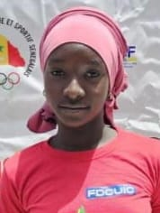
3ⁱèᵐ Place |  | Arame THIOUNE (Club Skate Parc) | 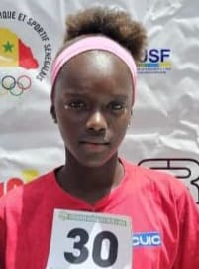
JUNIOR
1ᵉʳ Place |  | Marie Noelle BANDIAKY (Club Maestro Roller)
2ⁱèᵐ Place |  | Jeanne BASSENE (Club Maestro Roller)
3ⁱèᵐ Place |  | Amy SANE (Club Maestro Roller)

